CS/EE 120B

Custom Project: FitBit

Ji Hwan Kim

May 4, 2018

# Introduction

FitBit counts the user’s steps through an accelerometer and displays the number of steps taken on the LCD screen and the distance covered. The fitbit will also display the calorie burnt by calculating the number of steps taken.

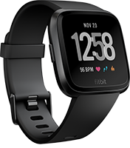

# Components (Pin-out)

* **Inputs**
  + Up and down buttons
  + Reset and start buttons
  + accelerometer
  + Bluetooth module
* **Outputs**
  + LCD screen. This will be used to display the steps taken
  + Bluetooth module

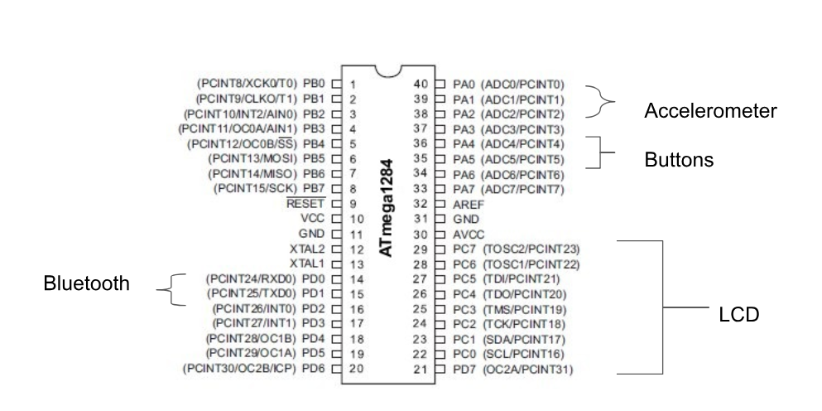

# Complexities/Build-upons

1. Using the **accelerometer** to measure footsteps
2. Using the **HC-05 bluetooth** module for communication between foot model (accelerometer and atmega) and wrist model (LCD and atmega)
3. Using a **second microcontroller** to enable footstep calculation while first is used for display and setting on the wrist